The Context

Welcome to the course, **Azure Essentials Continuum!**

This is a sequel to the **Azure Essentials** course, and in this course, we will focus on the

* **Azure IaaS services** like Virtual Machines, Vnets and Storage
* **Azure PaaS services** like Web Apps and Azure SQL

This course will offer both conceptual understanding and **Hands-On lab exercises** for you to play around with.

Please note that this course has been curated using the materials/resources received through our partnership with Microsoft. Hence, you could see that the content for this course has been taken from [Microsoft official sites](https://openedx.microsoft.com/).

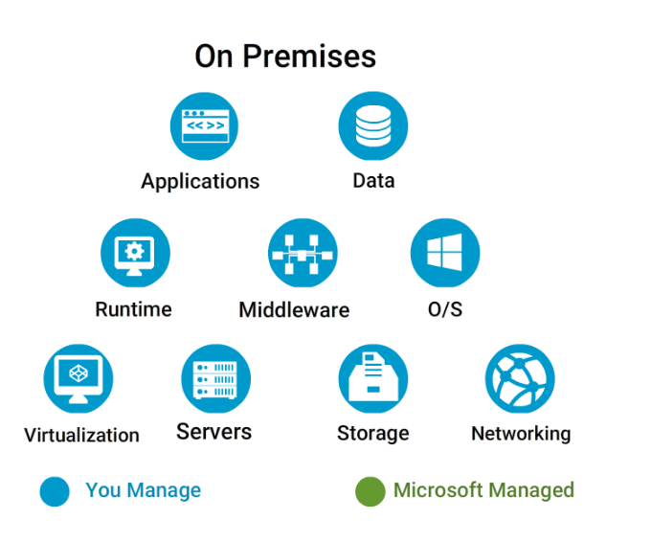

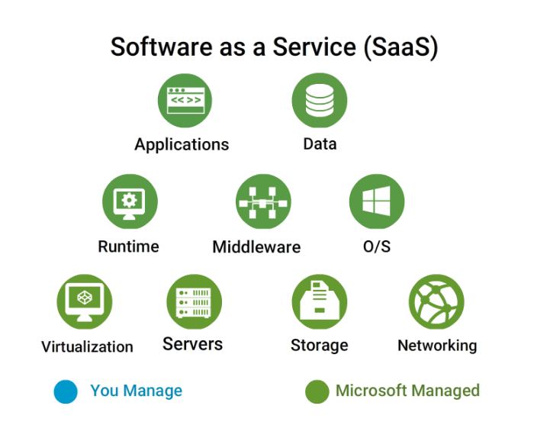

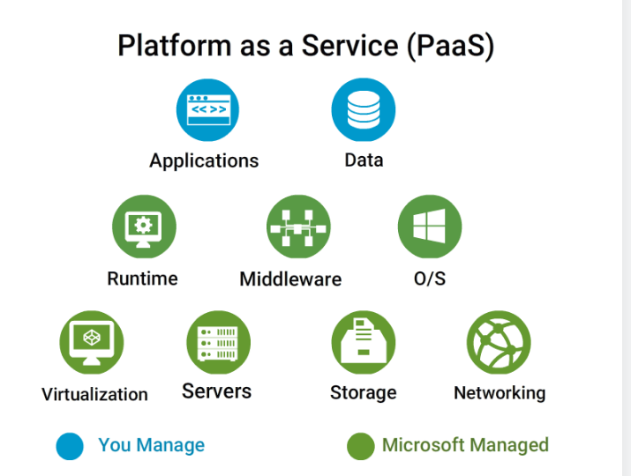

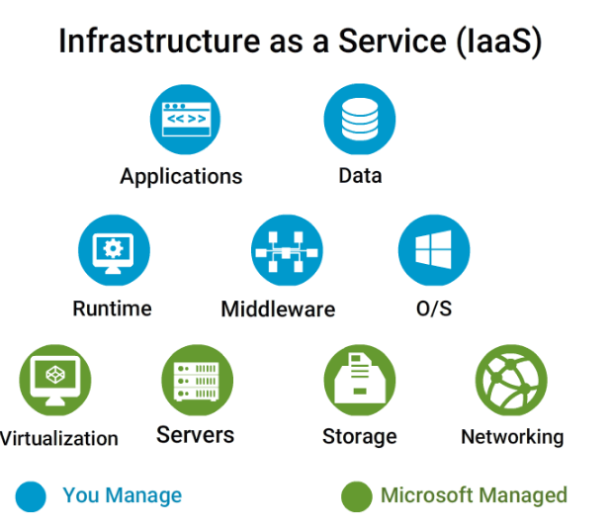

Azure is Microsoft’s cloud computing platform that enables individuals and organizations to create, deploy, and operate cloud-based applications and infrastructure.

It is highly scalable and flexible enough to integrate with your on-premises servers and data centers. Azure offers a number of services and resource offerings as:

* Infrastructure as a Service (**IaaS**)
* Platform as a Service (**PaaS**)
* Software as a Service (**SaaS**)

Azure Services

Microsoft Azure provides cloud services for accomplishing various tasks and functions across the IT spectrum and those services can be organized into several broad categories.

* Compute and Networking Services
* Storage and Backup Services
* Identify and Access Management Services
* Application Services
* Data and Analytics Services
* Media and Content Delivery Services

##### Azure Services: Compute, Storage, and Identity

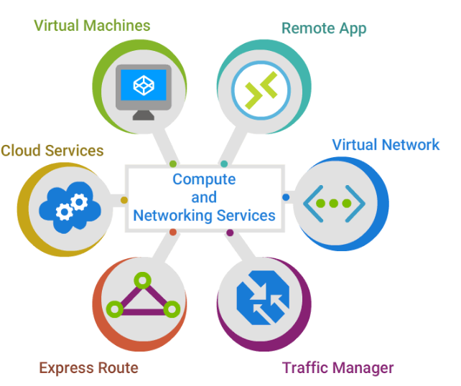

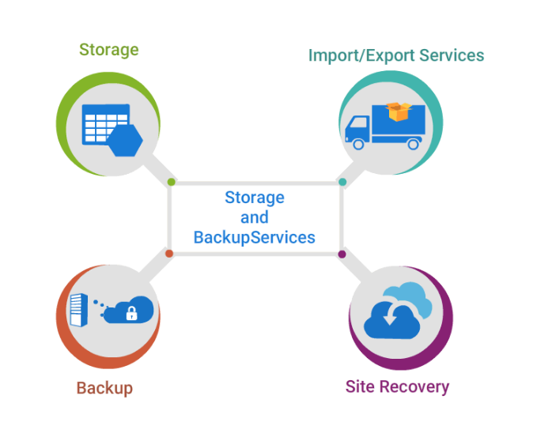

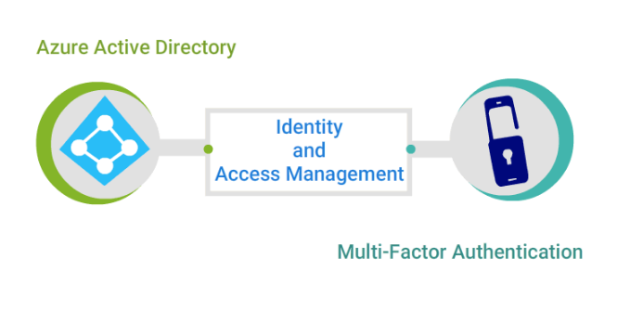

**Compute and Networking Services**

* **Virtual Machines**
* **Azure RemoteApp**
* **Azure Cloud Services**
* **Azure Virtual Networks**
* **Azure ExpressRoute**
* **Traffic Manager**

**Storage and Backup Services**

* **Azure Storage**
* **Azure Import/Export Service**
* **Azure Backup**
* **Azure Site Recovery**

**Identify and Access Management Services**

* **Azure Active Directory**
* **Azure Multi-Factor Authentication**

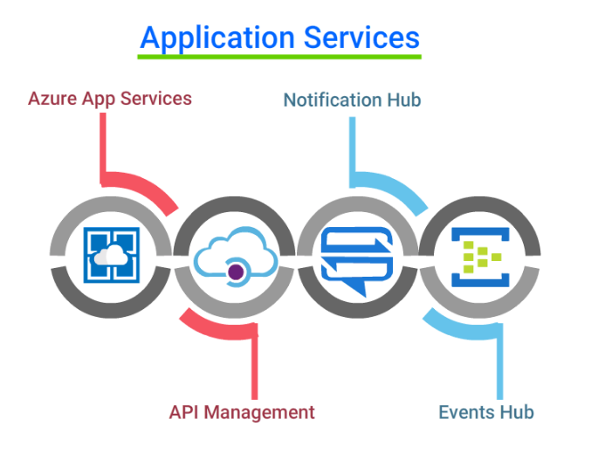

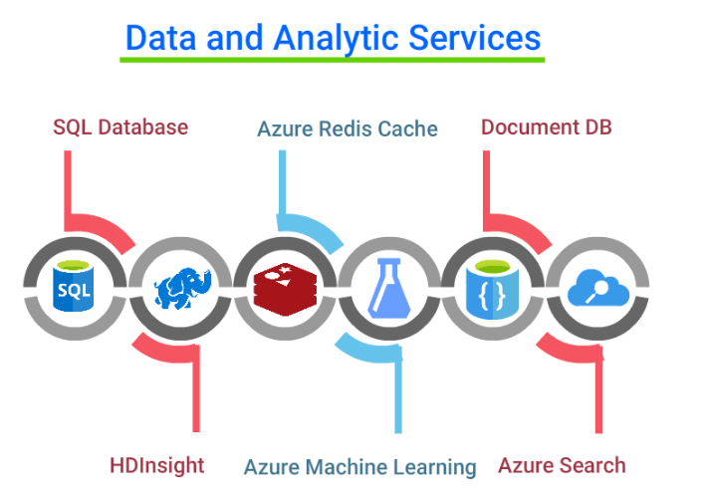

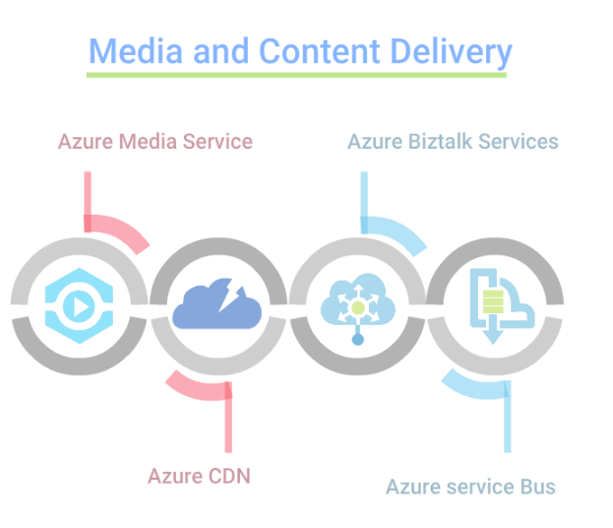

**Application Services**

* **Azure App Services**
* **API Management**
* **Notification Hubs**
* **Event Hubs**

**Data and Analytics Services**

* **SQL Database**
* **HDInsight®**
* **Azure Redis Cache**
* **Azure Machine Learning**
* **DocumentDB**
* **Azure Search**

**Media and Content Delivery Services**

* **Azure Media Services**
* **Azure CDN**
* **Azure BizTalk Services**
* **Azure Service Bus**

Azure Resources

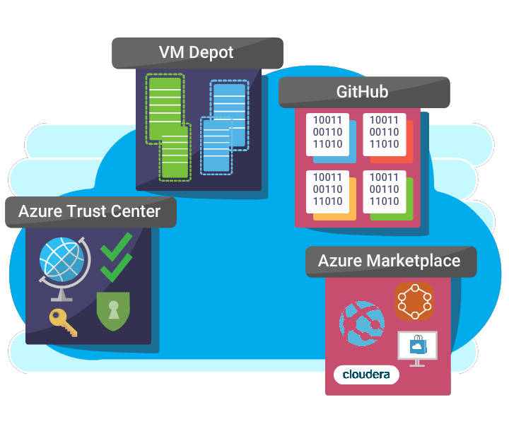

Now, let's get familiar with some of the useful resources that will help you manage your Azure environment.

* **Azure Marketplace**
* **VM Depot**
* **GitHub**
* **Azure Trust Center**

Azure Resources Contd...

**Azure Marketplace** - an online applications and services marketplace that offers,

* VM images and extensions
* APIs and Applications
* Machine Learning and Data services

**VM Depot** - a community-based catalog of open source virtual machine images that can be deployed directly from Azure.

**GitHub** - a web-based Git repository that is free to use for public and open source projects.

**Azure Trust Center** - offers guidelines for integrated security monitoring and policy management across Azure subscriptions. Also, it provides data security & data privacy guidelines essential to comply with regulatory controls.

##### Azure Subscriptions

Azure is a subscription-based service. You need to sign up for using any service.

You can purchase Azure through a number of different licensing options based on your business need. There are no upfront costs and you only pay for what you use.

Deploying Resources

Once you have your subscriptions in Azure, you will be able to deploy **Resources** like:

* **Virtual machine**
* **Storage account**
* **Virtual networks**
* **Services or any component** that you will be managing.

Azure offers two deployment models and multiple tools for you to be able to deploy and manage your resources.

##### Azure Deployment Models

1. **Azure Service Management Model (ASM)** using Classic Portal. This was the first approach that was introduced by Microsoft. Here the resources are coupled and can be deployed using ASM PowerShell Module.
2. **Azure Resource Management Model (ARM)** using New Portal. The resources are decoupled and hence can be configured independently. JSON templates provide simple orchestration and rollback functions. They have their own ARM PowerShell Module as well.

**For example**, while deploying a VM - compute, Vnet and storage resources are coupled in ASM, and hence can not be configured independently. Whereas with ARM, these resources are can be configured independently.

ARM is the recommended model of deployment and in this course, we align to this model.

Managing Resources

Azure offers a number tools that you can use to deploy, update or delete resources from your cloud solution. Resources can include virtual machines, storage accounts, virtual networks, services, or any component that you are managing.

Here are the tools at your disposal to manage resources,

* Azure PowerShell
* ARM and ASM Portals
* Azure CLI
* Azure Rest APIs
* Azure SDKs

**We will go in detail about these tools in this topic**.

Azure PowerShell

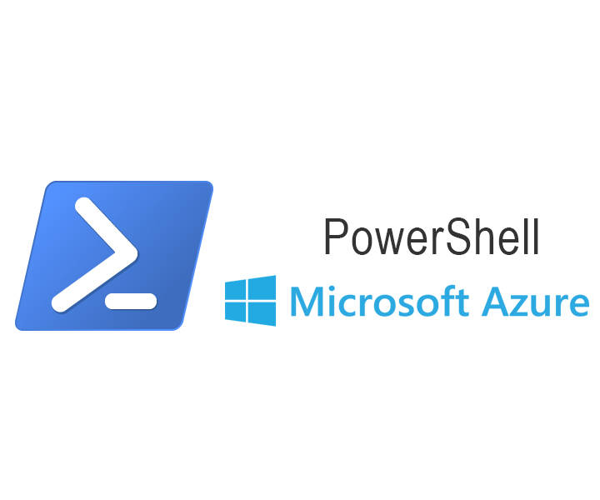

Azure PowerShell provides a set of cmdlets for managing your Azure resources and for Automating the scheduled task.

Azure PowerShell Module can be installed in several different ways,

* **From PowerShell Gallery**
* Using MSI installer **from the GitHub repository**
* Using **Microsoft Web Platform Installer**

In this course, we will cover the first two ways of installing PowerShell.

Installing Azure PowerShell from the PowerShell Gallery is most preferred.

Preparing to Install

Check if **PowerShellGet** is installed on your system using:

>Get-Module PowerShellGet -list | Select-Object Name,Version,Path

* If PowerShellGet is not installed, it can be downloaded from <https://www.microsoft.com/en-us/download/details.aspx?id=51451>.

Once PowerShellGet is downloaded you are all set to Install PowerShell ARM or ASM modules. We will look into this, in next couple of cards.

Administrative Privilege is needed to install the Azure PowerShell and Scripting environment must be enabled.

Install ARM Module

* You can install Azure Resource Manager (ARM) modules from the PowerShell Gallery using:

Install-Module AzureRM

* PowerShell gallery is not configured as a Trusted repository. Hence you will be prompted to "Allow installing modules from **PSGallery**". Choose 'Yes' or 'Yes to All' to continue.
* Once installed, load the module in the PowerShell session using:

Import-Module AzureRM

* Validate the installation by Checking the version of Azure PowerShell using:

Get-Module AzureRM -list | Select-Object Name,Version,Path

Install ASM module

* For Classic mode use following command to install Azure PowerShell,

Install-Module Azure

and

Import-Module Azure

* Validate the installation by Checking the version of Azure PowerShell using:

Get-Module Azure -list | Select-Object Name,Version,Path

##### Install Using Git Repo

Watch this video to learn how to **Install and Configure Azure PowerShell** using MSI installer from Git Repository.

Once you installed the ms azure powershell,open it and do execute below command to create account.

* add azurezccount -> it will let you link online azure account

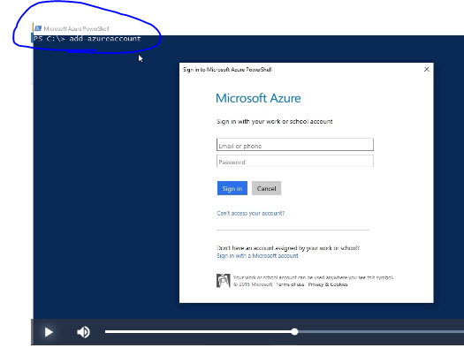

Once I supply my account details it will display like below.

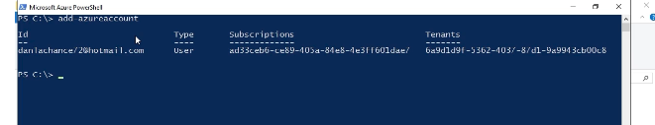

* get azurewebsite -> it will display all available websites for your subscription.
* New azurewebsite fakesite1 -> to create the new web site

##### ARM and ASM Portals

* **Azure Service Management (ASM)** is the traditional way of provisioning Azure Resources. **ASM portal**, also called **Classic Portal** uses ASM API calls to provision and manage Azure resources.
* **Azure Resource Manager (ARM)** is the service that is now more widely used to provision resources on Azure. The **ARM Portal** also called the **New portal** uses ARM API calls to provision resources. Also, when you use tools like Azure PowerShell, you are invoking ARM API calls.

While Microsoft supports both these portals and API’s, lot more features are being added to ARM on a regular basis. Hence it is recommended to use ARM - the new API’s, and portal to provision and manage resources.

##### Advantages of ARM

* **Resource Group** - ARM groups resources, making it much easier to manage them.
* **Smarter Provisioning** - ARM refers **ARM templates** to figures out resource requirement, dependencies and provisions resources optimally.
* **Role-based Access control(RBAC)** - gives greater control by configuring role-based access control at resource and resource group levels.
* **Tags** - can be applied to resources to logically organize all of the resources in the same subscription.
* **Billing** - In an organization, costs can be viewed for the entire group or for a group of resources sharing the same tag.

##### ARM Templates

**ARM templates** are commonly used to automate deployment. Resource groups and resource properties like the size of DB, type of storage account are defined in these **JSON documents**.

ARM inspects requirements in ARM templates, figures out resource dependencies and provisions resources in an order or even simultaneously when there is no direct dependency between certain resources.

* **GitHub Resource Manager** contains a number of [Azure Quickstart Templates](https://github.com/Azure/azure-quickstart-templates) which can be used to build and deploy.
* Another option is to **create custom templates**, using **JSON Editor**. **Visual Studio** or **Visual Studio Code** a lightweight, open-source editor can be used to create these templates. Visual Studio Code can be downloaded from [code.visualstudio.com](https://code.visualstudio.com/).

##### Creating ARM Templates

This video explains the step to create the custom template and also how utilize the Git Hub quick start templates.

Azure CLI

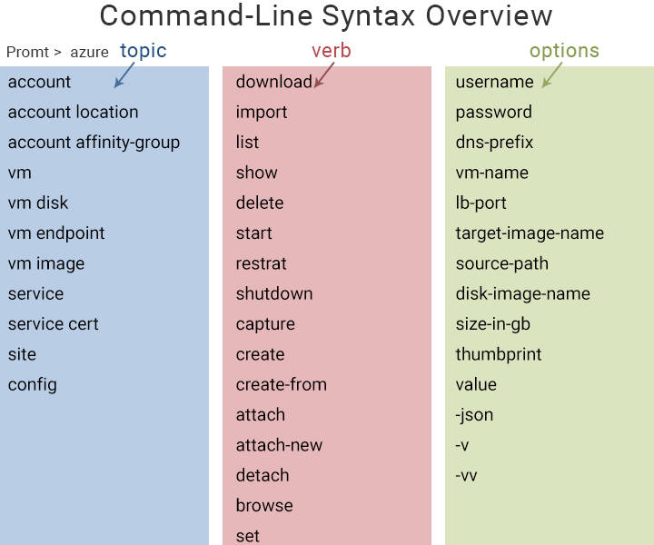

**Azure CLI 2.0** is an open-source, cross-platform, shell-based command line interface for managing Azure resources.

You can use it in your browser with **Azure Cloud Shell**, or you can install it on macOS, Linux, and Windows and run it from the command line.

**Commands are structured as:**

>azure <topic> <verb> <options>

or

>az <topic> <verb> <options>

* Example to list the virtual machines within an account

>azure vm list

* Example to create a resource group named "MyRG" in the centerus region of Azure

>az group create -n MyRG -l centerus

##### Azure REST APIs

One of the most powerful ways to manage Azure is via the Azure REST APIs. Representational State Transfer (REST) APIs are service endpoints that support sets of HTTP operations (methods) to manage your resources.

**It forms the connecting glue between your applications and Azure**.

**Test Drive Azure REST APIs**

You can interact with the Azure REST APIs in a number of ways and methods, you can try out and experience interacting with the Azure REST APIs using <https://azure.github.io/projects/apis/>

REST APIs adhere to the OpenAPI Specification (also known as Swagger 2.0).

##### Azure SDKs

**Azure SDKs provide a framework which you can use to build, deploy and manage various solutions and services you may need on Azure**.

**Some Azure SDKs currently available for download are**

* .NET
* Java
* Node.js
* PHP
* Python
* Ruby
* GO

**Azure SDKs are downloadable from** <https://azure.microsoft.com/en-in/downloads/>

**A series of SDKs available tailored for specific workloads or services are**

* IoT SDKs
* Media
* WebJobs

##### Resource Management - Summary

By now you should have a fair idea about various tools you can use to manage resources on Azure.

Next, you will learn in detail about various Azure resources like Virtual Machine, Vnet, Storage, etc and try to install them on your Azure Subscription.

Virtual Machines - F5

In the previous course **Azure Essentials** we had learned about various compute options offered by Azure. Also, we learned briefly about Virtual Machines and some of the key concepts like:

* Resource Groups
* Availability Set
* Auto Scaling
* VM creation Tools

Now, let us go further and understand VM sizes, supported OS and also create VM in your Azure Subscription.

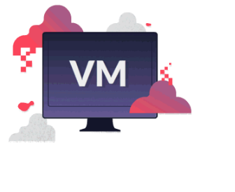

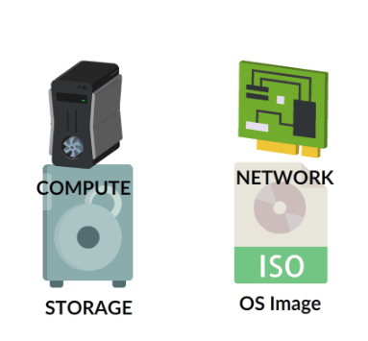

When to use VMs

Azure VMs are best for workloads that:

* Require High availability
* Experience Unpredictable Growth
* Experience Sudden Spikes

Over next few cards, we will learn how to create Azure VMs.

Virtual Machine Sizes

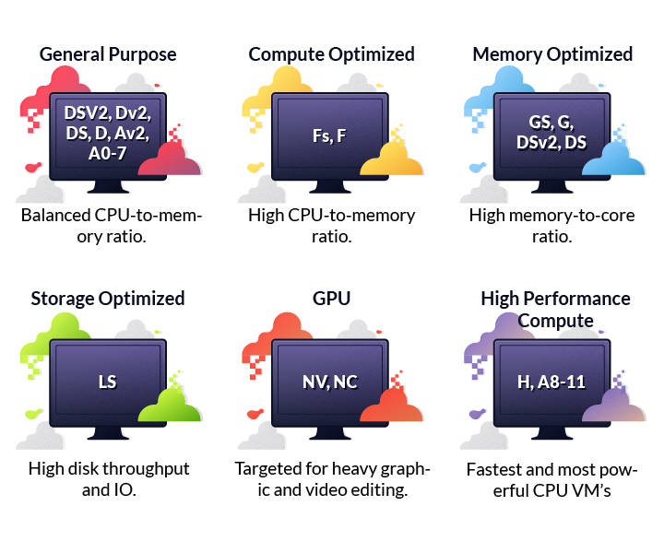

**The first Step to creating VM is to choose the right VM size**. Here are the various VM sizes that can cater to every kind of requirement.

* **General Purpose** - ideal for Testing and Development.
* **Compute Optimized** - recommended for medium traffic web servers and network appliances.
* **Memory Optimized** - used for relational DB servers, medium to large caches, and for in-memory analytics.
* **Storage Optimized** - used for Big Data, SQL, and NoSQL databases.
* **GPU** - Ideal for heavy graphic rendering and video editing.
* **High Performance Compute** - optimal for high-throughput network interfaces (RDMA).

Azure Market Place

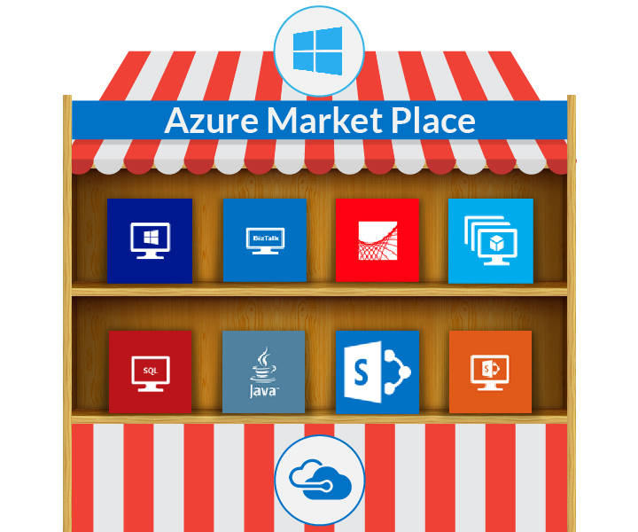

**Once the VM sizing is computed, OS images that are available in Azure Marketplace are used for provisioning a VM.**

Azure Marketplace provides a large image gallery, which includes:

* Recent operating system images of Windows Server, Linux, and SQL Server.
* You can also store your own images in Azure, by capturing an existing virtual machine and uploading the image.

Supported OS for Azure VM

**Windows Server**

* Windows Server 2008 R2 and later versions are available in **Azure Market Place**.
* Windows Server 2003 and later versions are supported for deployment. However, OS images must be uploaded from On-Premises.

**Linux OS**

* Azure supports many Linux distributions and versions including CentOS, Core OS, Debian, Oracle Linux, Red Hat Enterprise Linux, and Ubuntu.

Microsoft does not support OS that is past their End of Support date without a Custom Support Agreement (CSA). For example, Windows Server 2003/2003 R2.

Creating Virtual Machines

Finally, now to create Azure VMs any of the following tools can be leveraged,

* Azure portal
* ARM Template
* Azure PowerShell
* Azure CLI

**Basic steps for deploying a virtual machine**

* Select an image or disk to use for the new virtual machine from **Azure Market Place**.
* Provide **Required information** such as hostname, username, and password for the new virtual machine.
* Provide **Optional information** like domain membership, virtual networks, storage account, cloud service, and availability set.
* Go ahead and provision the machine.

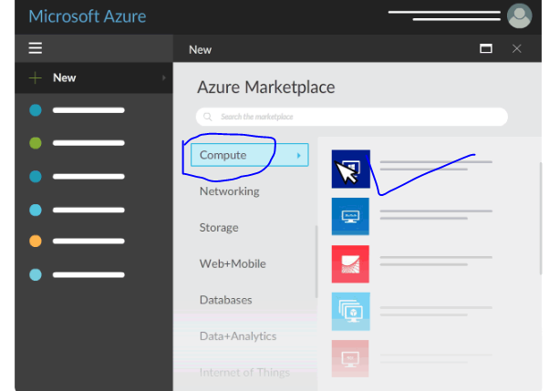

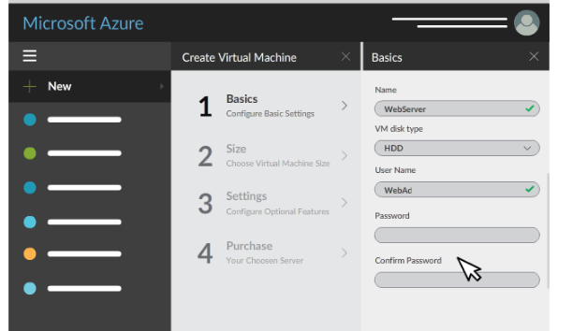

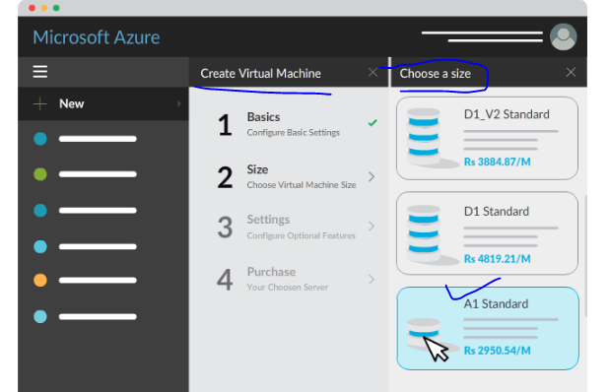

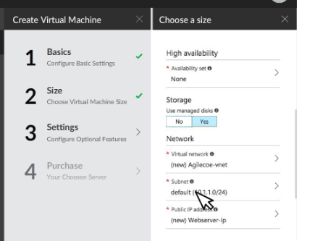

Azure Virtual Network

Once you create a VM, you will need to place it in a virtual network to receive IP address configurations and to connect to other VMs or other resources that you create in Azure.

**In this topic, you learn:**

* Vnet Creation
* Multiple Network Interface Card(NIC) usage
* Network Security Group(NSG) and NSG Rules

You can create Azure network resources by using either the **ARM Portal, Classic Portal, Network Configuration File, Azure PowerShell module, Azure command-line interface (Azure CLI)**, or by using deployment templates.

##### Creating Vnet using ARM Portal

Microsoft recommends Azure Resource Manager for deploying Vnet. Hence in this course, we will be using ARM portal for creating subnets and Vnets.

##### Multiple NICs in Virtual Machines

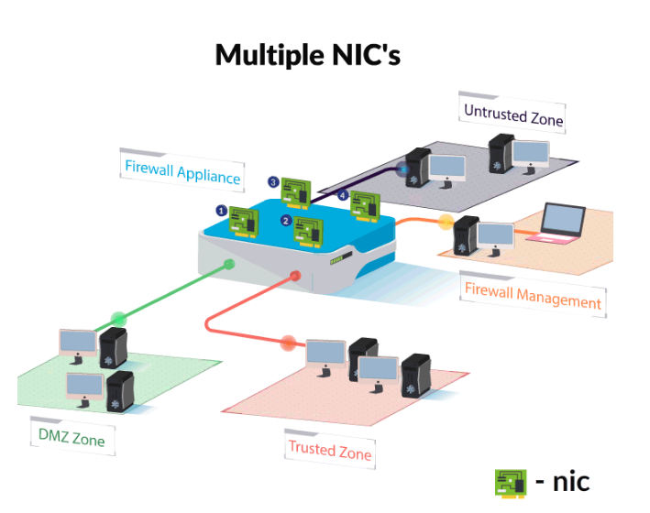

You can attach multiple network interface cards (NICs) to each of your VMs.

Multiple NICs are used for many network virtual appliances and WAN Optimization solutions, as it provides **high network traffic management capability**, including **isolation of traffic** between a front-end NIC and back-end NIC(s).

**Example** - Palo alto Firewall appliance which contains 4 NICs for,

* DMZ
* Trusted Zone
* Untrusted Zone
* Firewall Management

##### Limitations of Multiple NICs

* All VMs in a **Availability set need to use either multi-NIC or single NIC**. There cannot be a mixture of multi-NIC VMs and single NIC VMs within an availability set.
* Once deployed, a **VM with single NIC cannot be configured with multi NICs** (and vice-versa), without deleting and re-creating it.

Power shell script to create multi NIC’s

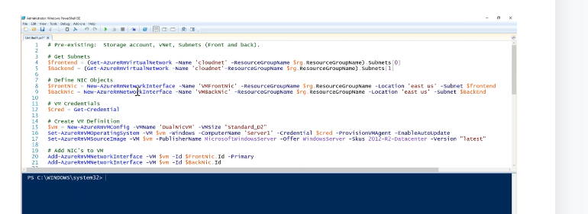

Network Security Groups

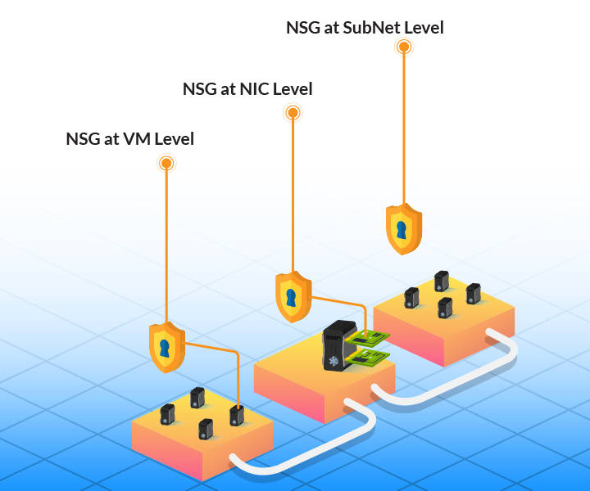

VMs can have connectivity to the Internet when public IP address is assigned to the VMs or to the cloud service. Under such scenarios, **Network Security Group (NSG) provides advanced security protection for the VMs**.

NSGs contain inbound and outbound rules that specify whether the traffic is approved or denied.

***NSGs Rule can be applied at the following levels***,

* **NIC** (ARM deployment model)
* **VM** (classic deployment)
* **All VMs in a Subnet** (both deployment models)

NSG - Example

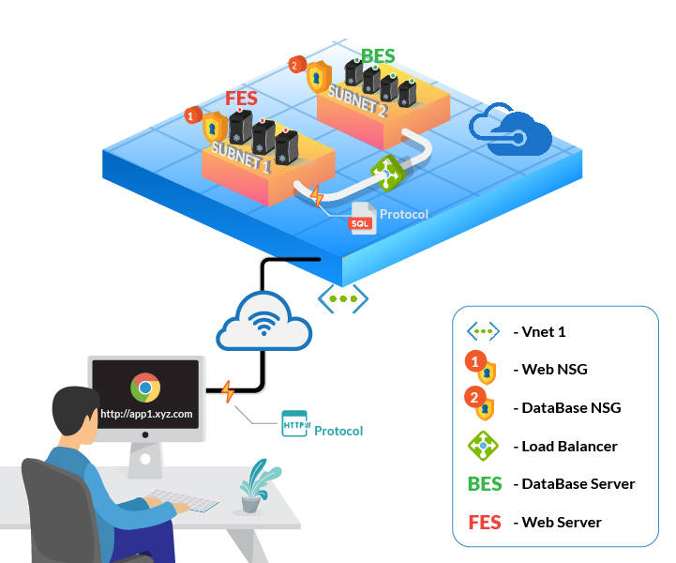

Consider a requirement where **Application Server should communicate with Internet (User) using HTTP Protocol only**.

* To achieve this, **NSG1 - web-rule** can be set to **allow HTTP traffic** to the FrontEnd subnet.

Also, assume a requirement where **DataBase Server should not communicate with internet and it should get SQL traffic only from Application Server**.

For this, NSG2 - DB Rule can be set as

* **sql-rule** to **allow SQL traffic only** from the FrontEnd subnet.
* **web-rule** to **deny all internet bound traffic** from the BackEnd subnet.

NSG Rule Properties

* **Name** - is a unique identifier for the rule.
* **Direction** - specifies whether the traffic is inbound or outbound.
* **Priority** - If multiple rules match the traffic, rules with higher priority apply.
* **Access** - specifies whether the traffic is allowed or denied.
* **Source IP address prefix** - identifies from where traffic originates.
* **Source port range** - specifies source ports.
* **Destination IP address prefix** - identifies the traffic destination IP range
* **Destination port range** - specifies destination ports
* **Protocol** - specifies a protocol that matches the rule.

##### Creating NSGs

Now that you understand what and why NSGs ae used, lets learn association of NSG with various network components and creation of Inbound and Outbound rules.

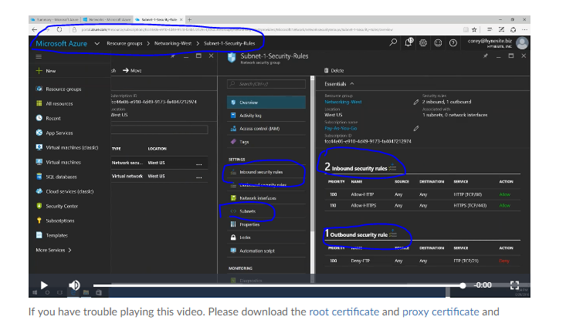

##### Things to Remember

* By default 100 NSGs can be created per region per subscription. This can be extended to 400 by contacting Azure support.
* A single NSG can have 200 rules which can be raised to 500 by contacting Azure support.
* Only one NSG can be applied to a VM, subnet, or NIC. However, the same NSG can be applied to multiple resources.

##### Another topic Intersite Connectivity Options

It is very common to come across a scenario where you have an On-Premise data center that needs to connect to resources deployed on Azure. There are four different options to handle such scenarios.

**Point to Site VPN** and **Site to Site VPN** were covered in detail in the **Azure Essential** course, So, now we will concentrate on **Vnet to Vnet Connectivity** and **Express Route**

##### VPN Gateway

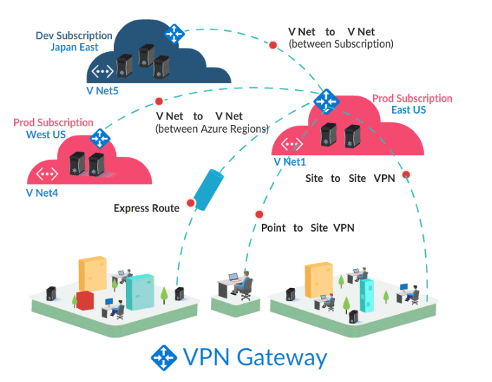

All 4 types of VPN connections require a **Virtual Network gateway** in the virtual network, which routes traffic to the on-premises computers.

The following VPN connections requires VPN Gateway:

* **Point-to-site**
* **Site-to-site**
* **VNet-to-Vnet** - Between different Azure Regions - Between different Azure Subscription
* **IaaS v1 VNet-to-IaaS v2 VNet**
* **Multisite**
* **ExpressRoute**

Features of VPN Gateway

A VPN gateway is a type of **virtual network gateway** that sends encrypted traffic across Azure virtual networks and also from Azure virtual network to an on-premises location.

* Each virtual network can have **only one VPN gateway**.
* **Multiple connections** can be made with the same VPN gateway.
* When multi VPNs connect to the same VPN gateway, **all VPN tunnels share the bandwidth that is available for the gateway**

##### ExpressRoute Connectivity

Microsoft Azure ExpressRoute can be used to extend the on-premises networks into the Microsoft cloud over a dedicated private connection. Watch this video to understand further about ExpressRoutes.

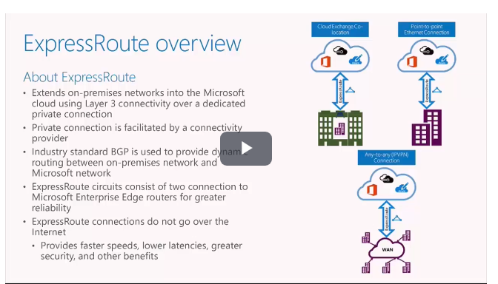

BGP – Handles all routing

Edge routers for great reliability

Advantages of ExpressRoutes

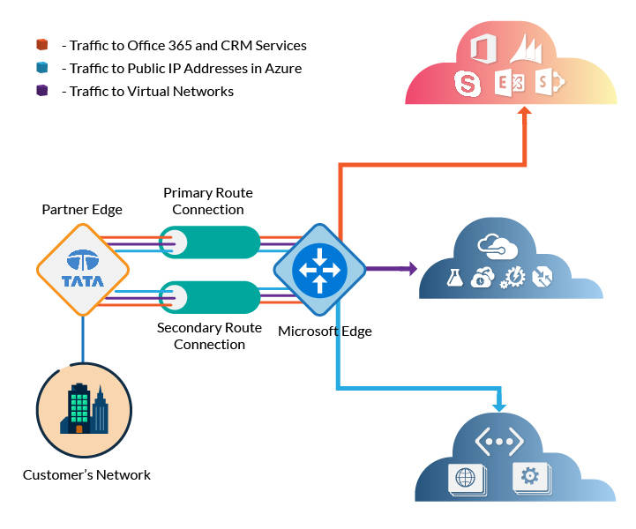

Typically ExpressRoute is used to establish the connections to Microsoft cloud services, such as Microsoft Azure, Office 365, and CRM Online. Also, it is used to transfer data between on-premises and Azure to achieve cost benefits.

Since they do not go over the public Internet, they are

* More Secure
* Highly Reliability
* Faster and Lower Latency

Considerations for Intersite Connections

**VPN Tunnel**

* Azure supports a maximum of 30 VPN tunnels per VPN gateway.
* Each point-to-site, site-to-site and VNet-to-VNet VPN counts as one of those VPN tunnels.
* Redundant tunnels are not supported.

**VPN Gateway**

* A single VPN gateway can support up to 128 connections from client computers.
* All VPN tunnels to a virtual network share the available bandwidth on the Azure VPN gateway.

**Address spaces**

* Address spaces must not overlap. Hence must be planned for virtual networks in Azure and on-premises networks.

17th Aug

##### Azure Storage F5

In **Azure Essential** course, we briefly learned about various storage services, replication methods, and finally about the hybrid cloud storage solution ***StorSimple***.

In this course, you will learn:

* **Performance tiers of Storage Accounts**
* **Features of Premium Storage**
* **Virtual Machine Storage**
* **Azure Files storage**
* **Azure Blob or Unstructured Storage**
* **Storage Tools**

##### Getting Started

To use any of the Azure Storage services like Blob storage, File storage, and Queue storage, you will first create a storage account, and then you can transfer data to/from a specific service in that storage account.

Once created, Azure Storage resources can be accessed by any language that can make HTTP/HTTPS requests. Additionally, Azure Storage offers programming libraries for several popular languages to simplify many aspects of working with Azure Storage.

We will learn about all of this in next few cards!

##### Azure Storage Areas

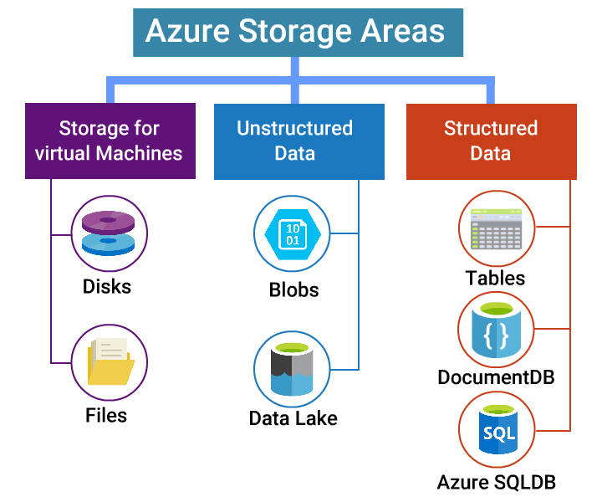

**Before we get started with creating Azure Storage, let us understand various Azure Storage Areas and Accounts.**

Azure storage is broadly grouped into 3 categories:

* Storage for Virtual Machines
* Unstructured Data storage
* Structured Data storage

##### Azure Storage Areas Contd...

**Storage for Virtual Machines**:

* **Disks** - Persistent block storage for Azure VMs.
* **Files** - Fully managed file share on the cloud.

**Unstructured Data storage**:

* **Blobs** - Highly scalable, REST based Cloud Object Storage.
* **Data Lake Store** - Hadoop Distributed File System (HDFS) as a Storage.

**Structured Data storage**:

* **Tables** - Key Value, high scale, auto-scaling NoSQL store.
* **DocumentDB** - NoSQL document database service.
* **Azure SQL DB** - Fully managed Database-as-a-service built on SQL.

You will learn more about **Disk and File** storage in next couple of cards. Structured and Unstructured data storages are covered in separate topics.

##### VM Disk Storage

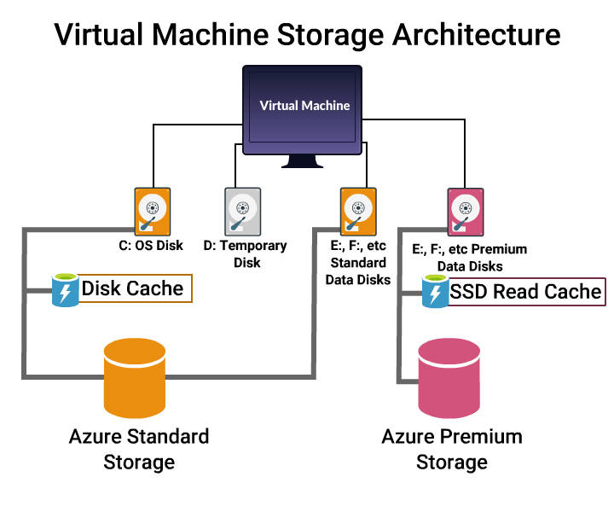

Virtual machines in Azure use disks as a place to store **Operating system, Applications, and Data**.

* VM's also can have one or more data disks
* Standard Storage Account uses **Hard Disk Drive(HDD)** as VM disk.
* Premium Storage Account uses **Solid State Drive(SSD)** as VM disk.
* Temporary Disk is a **Non Persistent storage and uses SSD storage**.
* All disks are stored as **Virtual Hard Disk's (VHD)**, and the maximum capacity of the VHD is limited to **1023 GB**.

It is not recommended to store any data on Temporary Disk.

##### VM Files storage

File storage offers shared storage using the standard SMB 3.0 protocol.

* It can be **accessed as a mounted drive or Map network Drive** as typical SMB share in Desktops.
* On-premises applications can access file data in a share via the **File storage API**.

**Common uses of File storage**:

* Applications that rely on file shares.
* Files like **Configuration files** that need to be accessed from multiple VMs.
* **Diagnostic data** like logs that can be written to a file share and processed later.
* **Tools and utilities** used by multiple developers.

##### Storage Accounts

**Types of General Purpose Storage Account**

* **Standard storage** - most widely used storage accounts that can be used for all types of data (tables, queues, files, blobs and VM disks).
* **Premium storage** - high-performance storage for page blobs, which are primarily used for VHD files.

**Performance tiers of Blob Storage Account**

* **Hot access** - for files that are accessed frequently. You pay a higher cost for storage, but the cost of accessing the files is much lower. Example: **File Share**.
* **Cool access** - to store large amounts of rarely accessed data for lower cost. Example: **Backup Data**.

##### Storage Account Conversion

* Standard storage accounts are backed by magnetic drives (HDD) and provide the lowest cost per GB.
* Premium storage accounts are backed by solid state drives (SSD) and offer consistent low-latency performance.

Hence it is not possible to convert standard storage account to Premium Storage account or vice versa.

##### Premium Storage



**Microsoft recommends using Premium Storage for all VMs.**

Premium storage has **high bandwidth with extremely low latency** and it offers less than 1ms read latency(cache). Also, premium storage disks for virtual machines support up to **64 TB of storage, 80,000 IOPS per VM and 50,000 IOPS per disk**.

* To improve total IOPS throughput we recommend striping across multiple disks and using SSD premium disks.
* Premium Storage is only supported on **Azure GS and DS series** of virtual machines.
* Premium Storage supports only **Locally Redundant Storage (LRS) Replication**.
* In Premium (SSD), the size of the VM disk is restricted to **128, 512, and 1023 GB**.

##### Storage Account Creation

Now that you understand a little about Storage types and accounts, let us learn how to create the Azure Storage Account.

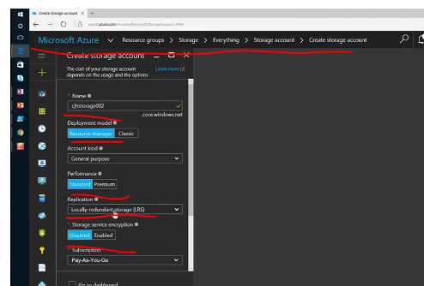

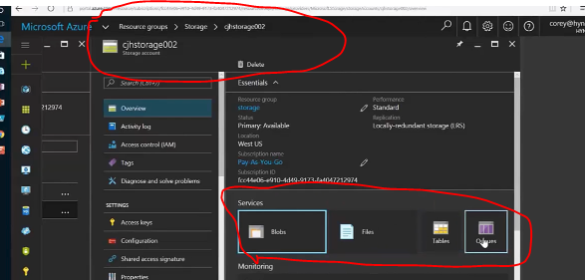

##### Storage Access Tools

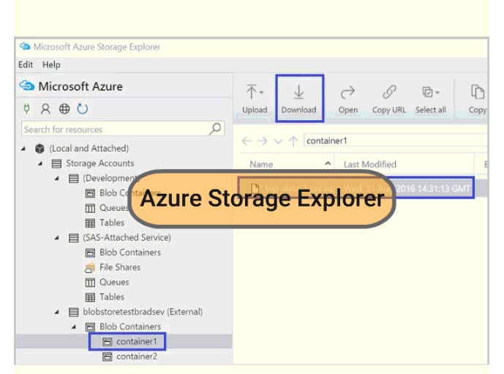

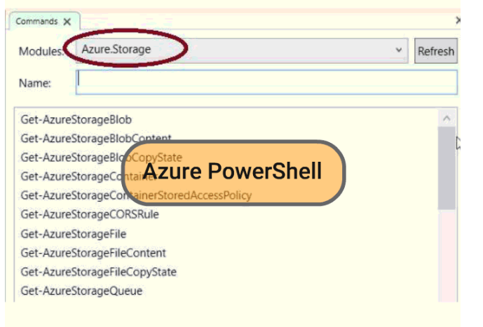

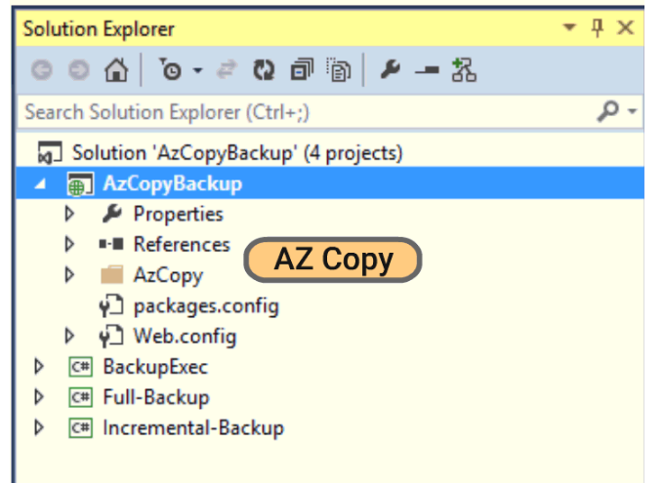

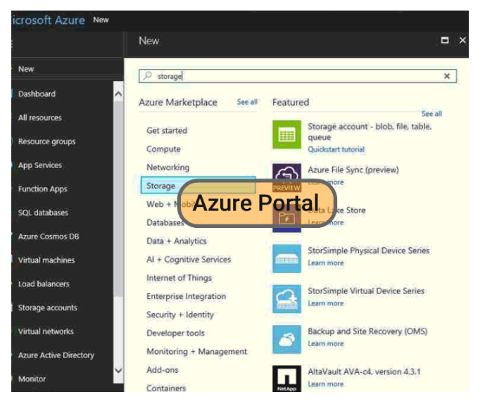

Azure Storage tools, make the life of a storage administrator much easier. Here are few of the most commonly used tools.

* **Azure Portal** and **Azure PowerShell**
* **Azure Storage Explorer** - a useful GUI tool to inspect and alter data in Azure Storage. It can be used to upload, download, and manage blobs, files, queues, and tables from any platform, anywhere.
* **AZ Copy** - a command-line utility to copy blob, and file data within a storage account or across accounts.
* **Azure Import/Export service** - to import or export large amounts of blob data to or from a storage account.

In this course we will learn about Azure Storage Explorer.

##### Azure Storage Explorer

This video explains about the installation of Storage explorer and uploading a file to Azure file storage.

##### Securing Storage

Azure Storage provides a comprehensive set of security capabilities which together enable developers to build secure applications.

**Data Security:**

* **Data in transit** can be secured using **client-side encryption, HTTPS or SMB 3.0 protocol**.
* **Data at rest** can be secured using **Storage Service Encryption**.
* **OS and Data disks** used by VMs can be encrypted using **Azure Disk Encryption**.

**Security Management:**

* **Storage Access Policy**: define policies to grant and revoke access at a granular level, with a time limit.
* **Role-Based access control**: use default and custom defined roles to control access to the storage accounts
* **Audit and monitor authorization**: using request information available in storage analytics logs.

Storage Account Access keys and Shared Access Signatures (SAS) can be used to secure data access.

##### Blob Storage Overview

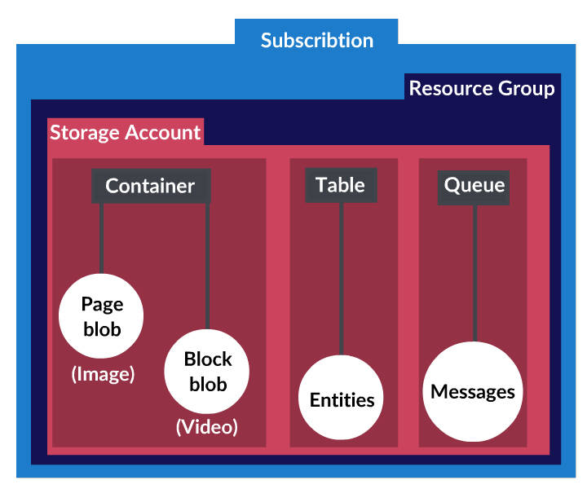

**Azure Blob storage is a service that stores Unstructured data in the cloud as blobs/objects**. All blobs must be in a container and a container can store an unlimited number of blobs.

**Common uses of Blob storage:**

* Serving images or documents directly to a browser.
* Storing files for distributed access.
* Streaming videos and audios.
* Storing data for backup & restore, disaster recovery, and archiving.
* Storing data for analysis by an on-premises or Azure-hosted service.

Blob storage is also referred to as **Object storage**.

##### Types of Blobs

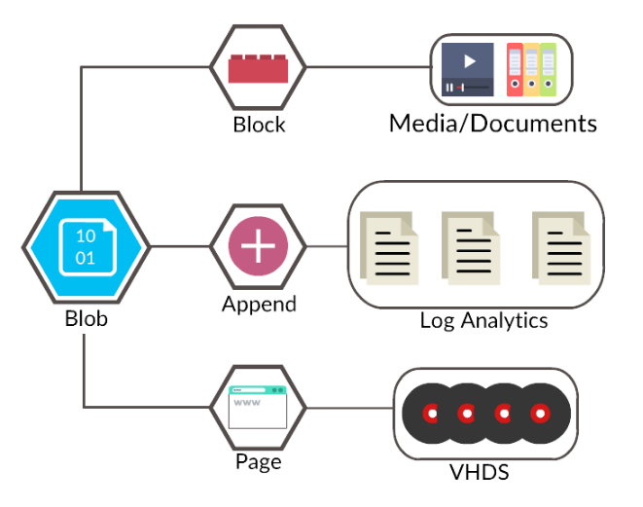

Azure Storage offers three types of blobs: **Block blobs, Page blobs, and Append blobs**.

**Block blobs**

* Suitable for **Sequential Read\Write** operations.
* Ideal for storing text or binary files, such as **documents and media files**.

**Append blobs**

* Optimized for **Append** operations.
* Can be used for **logging scenarios**.

**Page blobs**

* Optimized for **Random read/write** operations.
* Can be used for storing **VHD** files of Azure VM as **OS and Data disks**.

##### Managing Blob Storage

Blob storage typically requires transacting **Huge amounts of data** from On-Premises to Azure and vice-versa.

**Examples of Huge Data:**

* **Large Virtual Hard Disks (VHDs)** - Using Upload and Download Commands
* **TBs of Backup Data** - Using Export and Import services

Generally uploading and downloading VHD files is done through **Azure PowerShell or Storage Explorer**. Azure PowerShell provides a very efficient way for moving these large files through following **cmdlets**:

* **Add-AzureRmVHD** - Uploads a VHD from an on-premises virtual machine to a blob storage in Azure.
* **Save-AzureRmVHD** - Saves downloaded VHD images locally.

##### Uploading VHD

In this video, you will learn, how a VHD is uploaded from On-Premises to Azure.

##### Import and Export Service

Import and Export is another service that is suitable for scenarios when several TBs of data needs to be transferred. Transferring such volume of data over the network is not feasible due to limited bandwidth and high network costs.

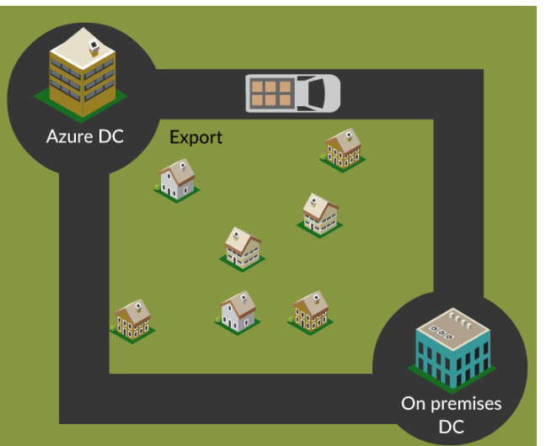

**Example:** Backup data to or from Azure.

* **Import Service** - Securely transfers large amounts of data to Azure blob storage by shipping hard disk drives to an Azure DC.
* **Export Service** - Transfers data from Azure blob storage to hard disk drives and ship to the on-premises site.

**Usage Scenarios:**

* Migrating data to the cloud.
* Content distribution to a different Datacenter.
* Backup and Recovery data.

##### Azure App Services - F5

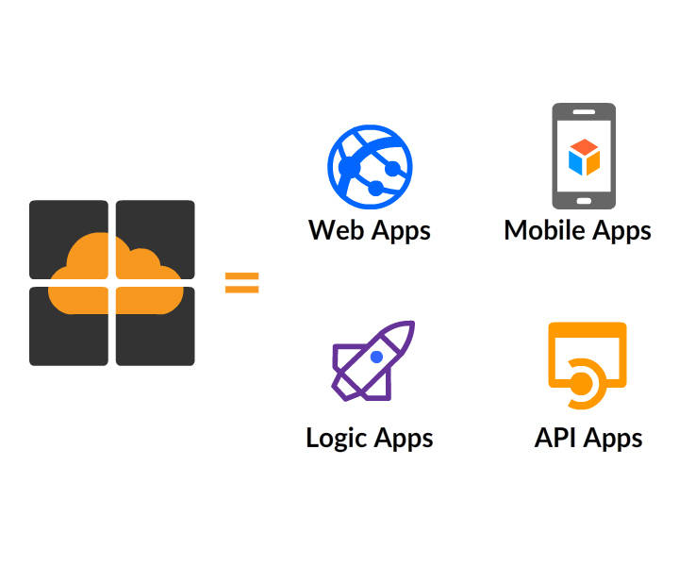

In **Azure Essentials** we briefly learned how Azure App Service enables us to easily create, Web, Mobile, Logic and API Apps.

* **Web apps**: web based applications that can scale with business requirements
* **Mobile Apps**: mobile applications that can run on any device
* **Logic apps**: For automating business processes and integrating systems and data across clouds without writing code.
* **API apps**: For hosting RESTful APIs that other services can leverage, such as in IoT scenarios

In this topic, we learn about Azure App Service Features, Plan and Environment.

##### Azure Momentum

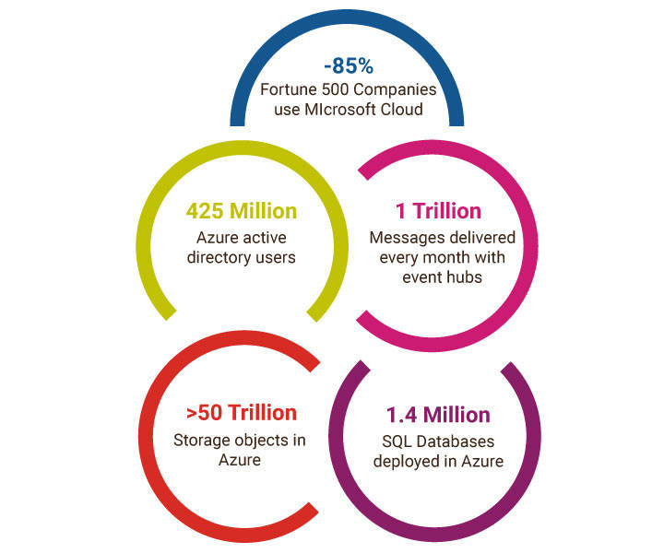

Global markets are now expecting:

* Deeper engagement with customers
* Faster times to market
* Scalability
* Availability
* Lower Costs

Azure App Services is gaining popularity and growing rapidly, as it helps teams meet these expectations. It offers flexibility, supports open source technologies and multiple languages for you to build your applications.

##### App Services - PaaS

We know that the Azure App Services works in PaaS model. In this video, we learn benefits of PaaS in Azure using a common example.

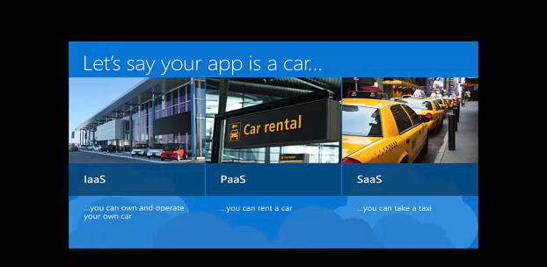

##### App Deployment Guide

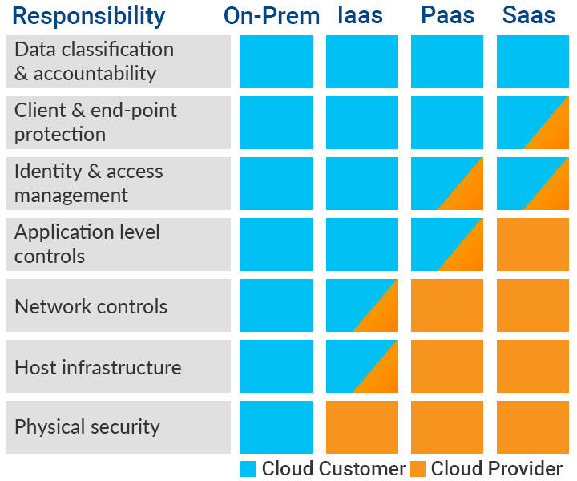

Areas of responsibility and control that needs to be retained can guide in deciding if the application should be:

* On-premises
* On Azure virtual machines as part of an IaaS offering
* Part of a PaaS offering
* just consuming the end product in a SaaS offering

##### Features of Azure App Services

Watch this video to understand the **Features of Azure App Services**.

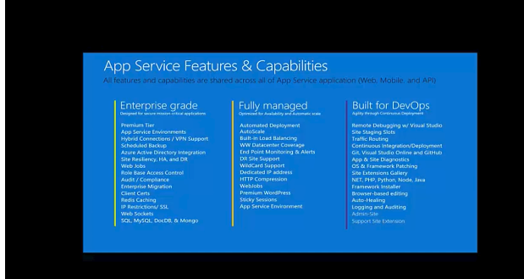

##### App Service Plan

**App Service plans define the capabilities and boundaries of the environment in which application has to run**.

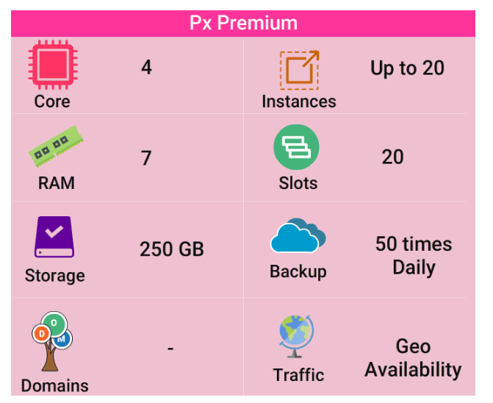

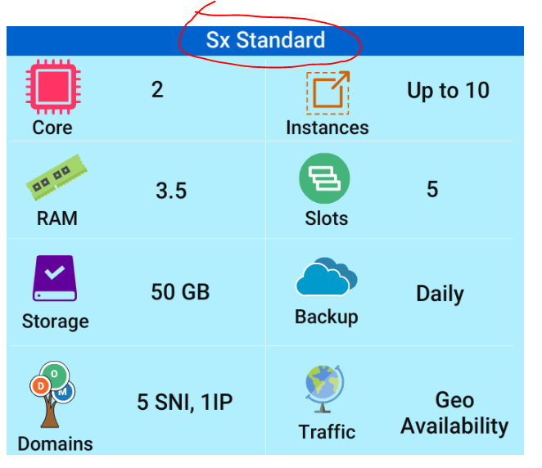

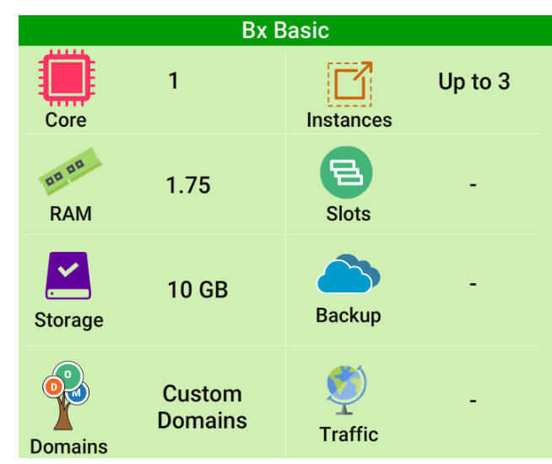

There are five layers available: **Free**, **Shared**, **Basic**, **Standard** and **Premium**.

**Note:**

* An application can only be associated with one service plan. However, a service plan can have, multiple applications associated with it.
* The application must be in the same subscription and geographic location to share a plan.
* Apps that share a plan can use all the capabilities and features that are defined by the plan's tier.

##### App Service Environment

Azure App Service Environment is a premium service plan offering within Azure App service that allows for more isolated environments within Azure App Service and the ability to run at higher scale and capacities.

Watch this video to know more.

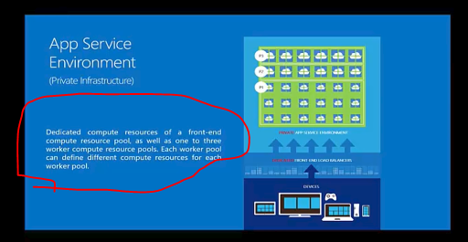

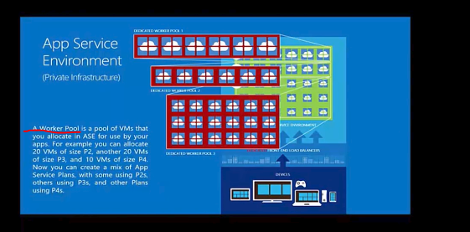

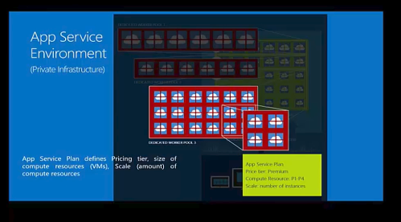

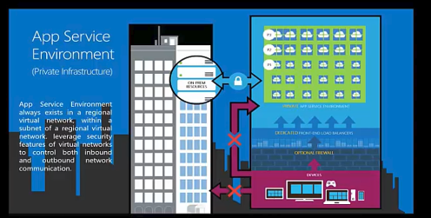

##### Management Tools

Like other Azure services, Azure App Service can also be managed by using the following tools,

* Azure PowerShell
* Azure Command Line Interface (CLI)
* REST APIs
* Templates
* ARM and ASM portals

In this topic, we will learn about **Locking Resources, Custom Domain name configuration, Site Extensions, and app deployment options**.

##### Locking Resources

Azure App Services protects the resources using **Locks**.

* Locks can be applied to a **subscription, resource group, or a resource such as a web application**.
* It prevents **deleting or modification of resources** by other users.

**Lock Levels:**

* **CanNotDelete**: where authorized users can read and modify a resource, but they can't delete.
* **ReadOnly**: where authorized users can read from a resource, but they can not perform any actions on it.

Locks are different from Role Based Access control(RBAC).

##### Adding a Lock

In this video, we will walk through the steps to add a lock to a website created in the Azure App services.

##### Custom Domain Name Configuration

When a Application is hosted on Azure, it can be accessed using a default domain name **<app name>.azurewebsites.net**.

However, **it is preferred to access the application using our own URL**, such as [https://play.fresco.me](https://play.fresco.me/)

Custom Domain name can be directly purchased through the **Azure App services portal** or one can carry forward their own Domain Name.

##### Configuring Custom Domain Name - Demo

This video explains the importance and step to create the custom domain for the App service.

##### Site Extensions with Apps

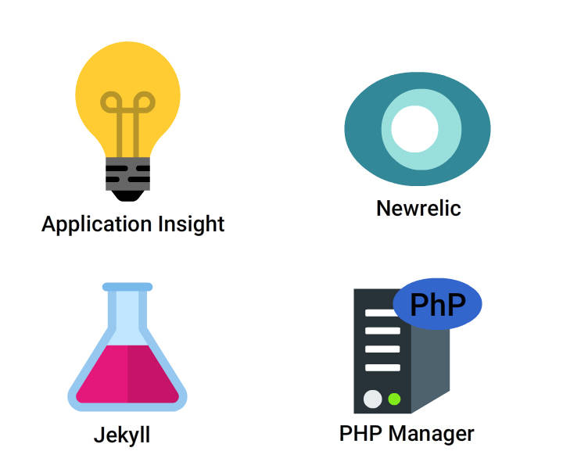

**Site Extensions are used to extend functionality and provides ease management of Web Applications**.

* A full list of available site extensions is available on the Site Exensions page, <https://www.siteextensions.net/>.
* It also provides pointers to project sites, licenses, owner details etc for each extension.

**Examples of Site Extensions:**

* **Application insights**: provides monitoring capabilities.
* **New Relic**: provides monitoring capabilities.
* **Php Manager**: tool for managing PHP installations.
* **Jekyll**: Adds support for Jekyll on a Web App.

##### App Service Deployment Options

There are a number of different options available for deployment of web app services such as,

**Basic**

* FTP
* Web Deploy

**Alternative**

* OneDrive/DropBox
* Kudu

**Source Control / Continuous Deployment**

* Visual Studio Online
* Local Git
* GitHub
* BitBucket

##### FTP Deployment

This video provides an overview of FTP Deployment.

##### Kudu based Deployments

Kudu is the engine behind source control based deployments into Azure App Service. Every Azure website has an associated 'scm' service site, which runs both Kudu and other Site Extensions.

**Accessing the Kudu service**

If your website URL is http://mysite.azurewebsites.net/, the root URL of the Kudu service is**https://mysite.scm.azurewebsites.net**.

##### Azure Database Services Intro

In **Azure Essentials** we learn about different types of Data services in Azure, such as,

* SQL Database
* SQL Data Warehouse
* Document DB
* Table Storage
* Redis Cache
* Data Factory
* Data Lake

In this course, we will focus on:

* **Difference between Azure SQL and SQL on Azure VM**
* **Architecture of Azure SQL and Service tiers**
* **Planning and Provisioning of Azure SQL**
* **Migrating SQL database to Azure**
* **HDInsight**

##### Database On Cloud

**One of the key decision points about where and how you want to run your SQL databases is the** **administrative Vs Cost overheads**.

There may be critical business requirements around data retention that must be adhered to in some scenarios. Sametime, there are instances where data is potentially suitable to be stored in the cloud either under a PaaS or an IaaS model.

Scenarios like these where there is a blend of answers, opting for a hybrid solution with some of the database needs to be met by using the cloud and other data being retained on-premises can help reduce management overhead and costs.

Azure SQL (PaaS) Vs SQL Server (IaaS)

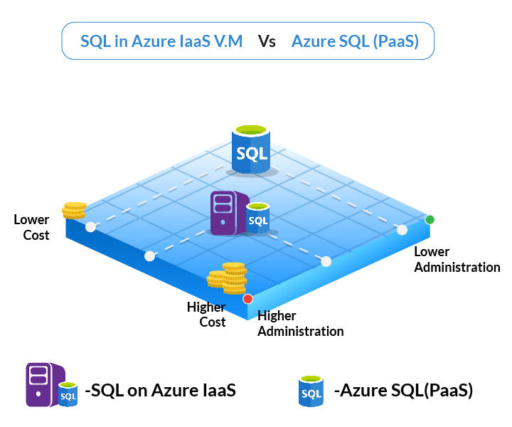

**Azure SQL Database (PaaS):** is native to the cloud and is optimized for SaaS app development. It reduces overall costs to the minimum for provisioning and managing many databases as you do not have to manage any VMs, OS or DB software.

**SQL Server on Azure Virtual Machines (IaaS):** is optimized for migrating existing applications to Azure or in hybrid deployments. It is a perfect choice when an organization already has IT resources available to maintain the VMs.

In general, these two SQL options are optimized for different purposes and needs to be determined based on the requirement.

##### Azure SQL - Architecture

In this video, we will discuss **Architecture of Azure SQL** and components involved SQL PaaS.

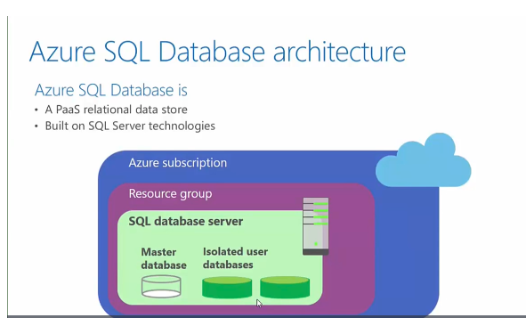

##### Database Transaction Unit

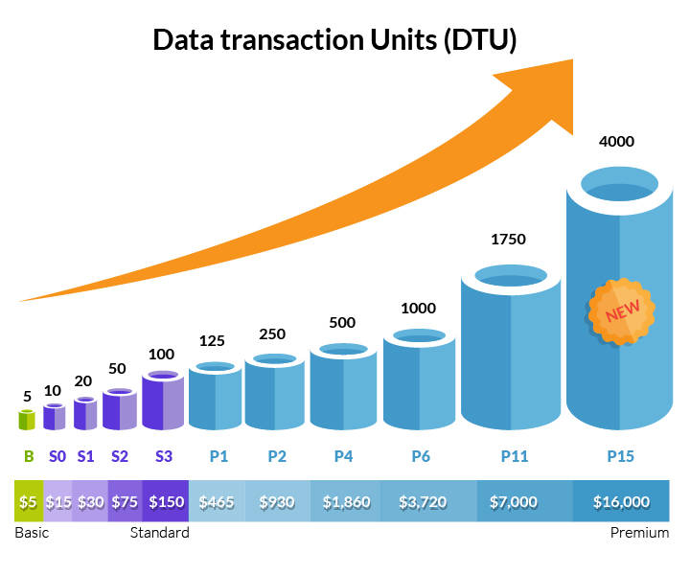

A DTU is a measure of the resources that are guaranteed to be available to a standalone Azure SQL database. **It is a measure that combines CPU, memory and I/O values**.

DTU is used to decide which Service Tier is suitable for your Database requirement.

**Larger the number, better the performance.** BTU provides a way to see the overall performance levels, need driving it and be able to relate that to cost.

An elastic DTU (eDTU) is a measure of the resources across a set of databases, called an elastic pool.

DB Service Tiers

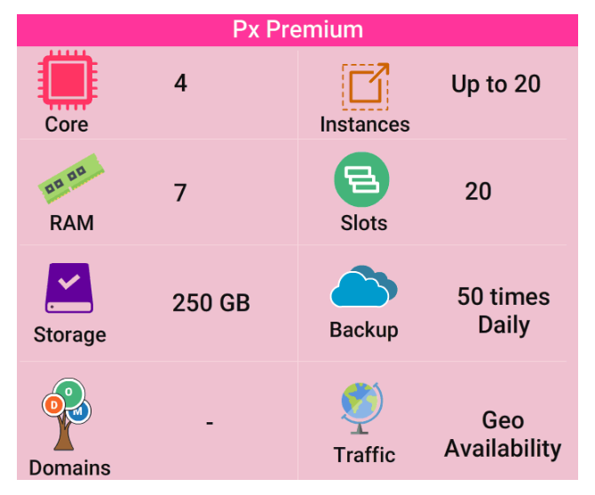

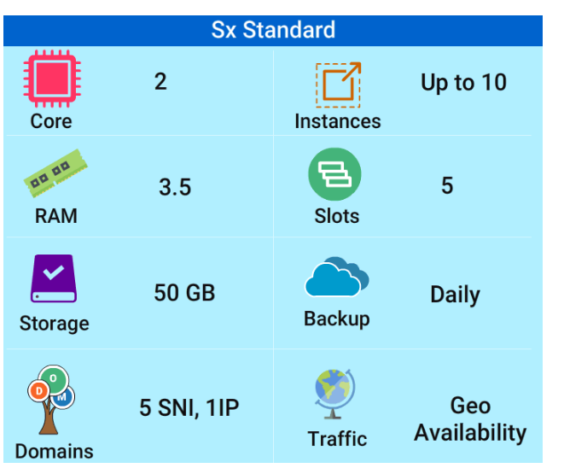

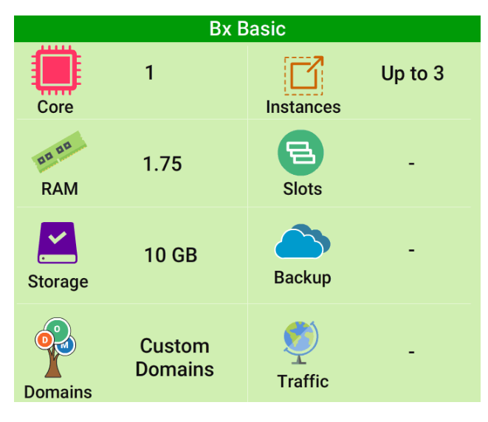

There are three different Service Tiers to accommodate a variety of workload requirements.

* **Basic** - Suitable for **small databases, and low volume needs**
* **Standard** - Suitable for most **cloud based apps**
* **Premium** - Suitable for **high transnational volumes with super critical workloads**

All these options provide an uptime SLA of 99.99% and hourly billing. Also, it is possible to change service tiers and performance levels dynamically.

##### Migrating SQL DB

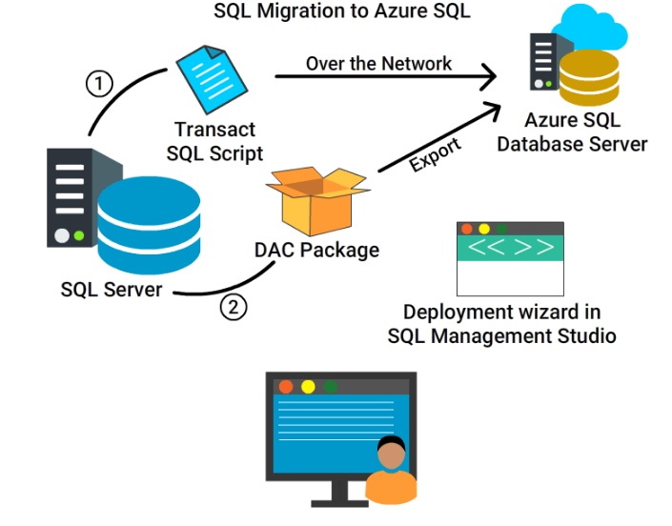

Quite often SQL DBs are migrated from On-Premises to Azure SQL.

**Pre-requisites of Migration**

* Test for compatibility of the DB with Azure SQL
* Fix Compatability issues if found
* Perform migration

***Migration can be done in multiple ways***, **Acceptable Downtime** decides the type of Migration.

* For minimal downtime, use **SQL Server transactional replication** and replicate your data over the Network.
* When downtime is acceptable, use **Export to DAC package and ImportDAC package in Azure SQL**

##### Data Analytics with HDInsight

**HDInsight is a Microsoft managed Hadoop service** running in Azure that provides a range of open source data analytics cluster models.

Microsoft makes the Hadoop components available in a distributed model in Azure where it manages the cluster. Making it easy to provision and manage them with high availability and reliability.

It is available as a service under the Intelligence and Analytics grouping of services wihtin Azure.

HDInsight - Cluster Types

HDInsight currently provides several different optimized open source analytic cluster types:

* **Hadoop** - Petabyte scale processing with Hadoop components like Hive, Pig, Sqoop.
* **HBase** - Fast and scalable NoSQL Offering.
* **Storm** - Allows processing of infinite streams of data in real-time.
* **Spark** - Fast data analytics and cluster using in-memory processing.
* **Interactive Hive** (preview) - Enterprise Data Warehouse with in-memory analytics using Hive and Long Live and Process (LLAP)
* **R Server** - Terabyte scale, provides enterprise-grade R analytics used for machine learning models.
* **Kafka** (preview): High throughput, low latency, real-time streaming platform, typically used in streaming and IoT scenarios

Azure Essentials Continuum - Course Summary

Congratulations! You have come to the end of this course. By now, you must have got a good idea about IaaS and PaaS services offered by Azure and various management tools,

* Compute
* High Availability and Scale set
* Virtual Networks
* Intersite Connectivity
* Storage Areas
* Azure PaaS
* Azure SQL
* Few other important services

All the concepts will be understood only if we do the hands-on ,,,,

Try out all the Hands-On in next topic.

We will go deep dive on these services in a separate courses. Keep Learning!

##### Getting Started Hands On Exercises

You learned the fundamental concepts of Azure Services. Now it is time to practice what you learned.

**Let's get started with the Hands-On exercises!**

The next few cards, provide details of the Hands-on exercises and the Step Guides to perform them.

You will receive an e-mail with username and password to your TCS e-mail address when you click on **Launch** button in the Hands-On lab card. Use these credentials to logon to Azure Subscription.

**It is important you do not share these credentials.**

Points to Consider

* If you are doing the Hands-On exercises on **TCS Network**, you may not be able to perform certain tasks like **connecting VM using RDP**. In such cases use the **Open Internet**.
* **Step Guides** have been uploaded in the Azure Storage for performing these exercises.
* **Steps to access the step guide** is given in the next card
* Use **ARM portal** for all your labs.
* Create all the objects in the Resource Group **Fresco_Azure_ESS_RG**.
* The objects created in the lab will be available only for 2 hours.

##### To Access the Step guide

Steps to access **Azure Fundamental lab guide:**

1. Sign in to the [Azure Portal](https://portal.azure.com/) with the given account.
2. Select **Storage** then click on the following storage account **frescotestst**
3. Select the **File** and search for **Azure Fundamentals** folder and click on the folder
4. Search for **Azure** ,you will find all the step guides ,**download the required ones**

##### Azure Hands-On Task

Try out the following Hans-On exercises:

1. Explore the ARM Portal and review the options of Azure Market place, Portal settings, Notification, billing and cost.
2. Create a Virtual Network.
3. Create a Virtual Machine.
4. Deploy a Web App in Azure Web Services.
5. Add a Lock to Your Web App to prevent it form being deleted.

**For 2 and 3 exercises refer the given configuration details, provided in the cards to follow**.

Create a Virtual Network

**Create Virtual Networks with below configuration**:

* Name: Yourname-Vnet
* Address space: 192.168.X.0/24
* Subnet name: Yourname-Subnet
* Subnet Address range: 192.168.X.0/22
* Resource Group: Existing Resource group **Fresco_Azure_ESS_RG**
* Location: South East Asia

Create a Virtual Machine

Deploy a **Windows Server 2012 R2** Virtual Machine using ARM Portal with the below configuration,

* **Name**: Yourname-Server
* **VM disk type**: HDD
* **User name**: *Your first name*
* **Password**: Pa$$w0rd12345
* **Subscription**: *Your Subscription*
* **Resource Group**: Existing Resource group "Fresco_Azure_ESS_RG "
* **Location**: South east Asia
* **Size**: A1 basic
* **Vnet**: FrescoAzureESS_RG-vnet
* **Subnet**: FrescoAzureESS_RG-subnet
* **Storage**: frescoazureessrg

##### Create a Storage Account

**Perform the following task** using the step guides in Azure.

1. Create a **Storage Account**.
2. Download [Storage Explorer](https://azure.microsoft.com/en-us/features/storage-explorer/) and install in the Azure VM that you have created**Yourname-Server** and access the above storage account.
3. Create a folder named **YournameFolder1** in the above storage account using Azure Portal and upload any file from your local computer to the "YournameFolder1" in Azure.